 ***East West University***

**Department of Computer Science & Engineering**

COMPILER PROJECT REPORT

**Course Title :**  Compiler Design

**Course Code :** CSE375

**Section :** 02

**Semester :** Fall 2019

**Submitted To:**

**Dr. Shamim H Ripon**

**Professor  
Department of Computer Science & Engineering**

**East West University**

**Submitted By**

**Md. Rajib Hawlader**

**ID: 2017-1-60-104**

**Nasif Wasek Fahim**

**ID: 2017-1-60-037**

**Date of Submission:** **5 December 2019**

Grammar

**grammar compiler;**

**root: header_file mainfunction;**

**header_file: '$' text;**

**text: 'Start';**

**mainfunction: 'mainfunction:' content;**

**content: '['inside_main']';**

**inside_main: (statement)+;**

**statement: expression**

**|ID '=' expression**

**|ID '++'**

**|ID '--'**

**|if_condition**

**|loop**

**;**

**expression: expression('*'|'/') expression**

**| expression ('+'|'-') expression**

**|INT**

**|ID**

**| '(' expression ')'**

**;**

**condition: ID relational_op expression;**

**if_condition: 'jodi' '('condition')' '[' (statement)* ']';**

**loop: 'loop' '('condition')' '[' (statement)* | 'break' ']';**

**relational_op:'>'|'<'|'>='|'=='|'<='|'!=';**

**INT:[0-9]+;**

**WS : [ \r\n\t]+ -> skip ;**

**ID:[a-z|A-Z]+;**

**INPUT**

**$ Start**

**mainfunction:**

**[**

**jodi(a > 4)**

**[**

**a = 30 * 4**

**b = a + (10*8)**

**]**

**loop(x > 11)**

**[**

**x=x+5**

**x++**

**jodi(x == 50)**

**[**

**break**

**]**

**]**

**jodi(b < 14)**

**[**

**x = 78**

**]**

**]**

**PARSE TREE OF INPUT**

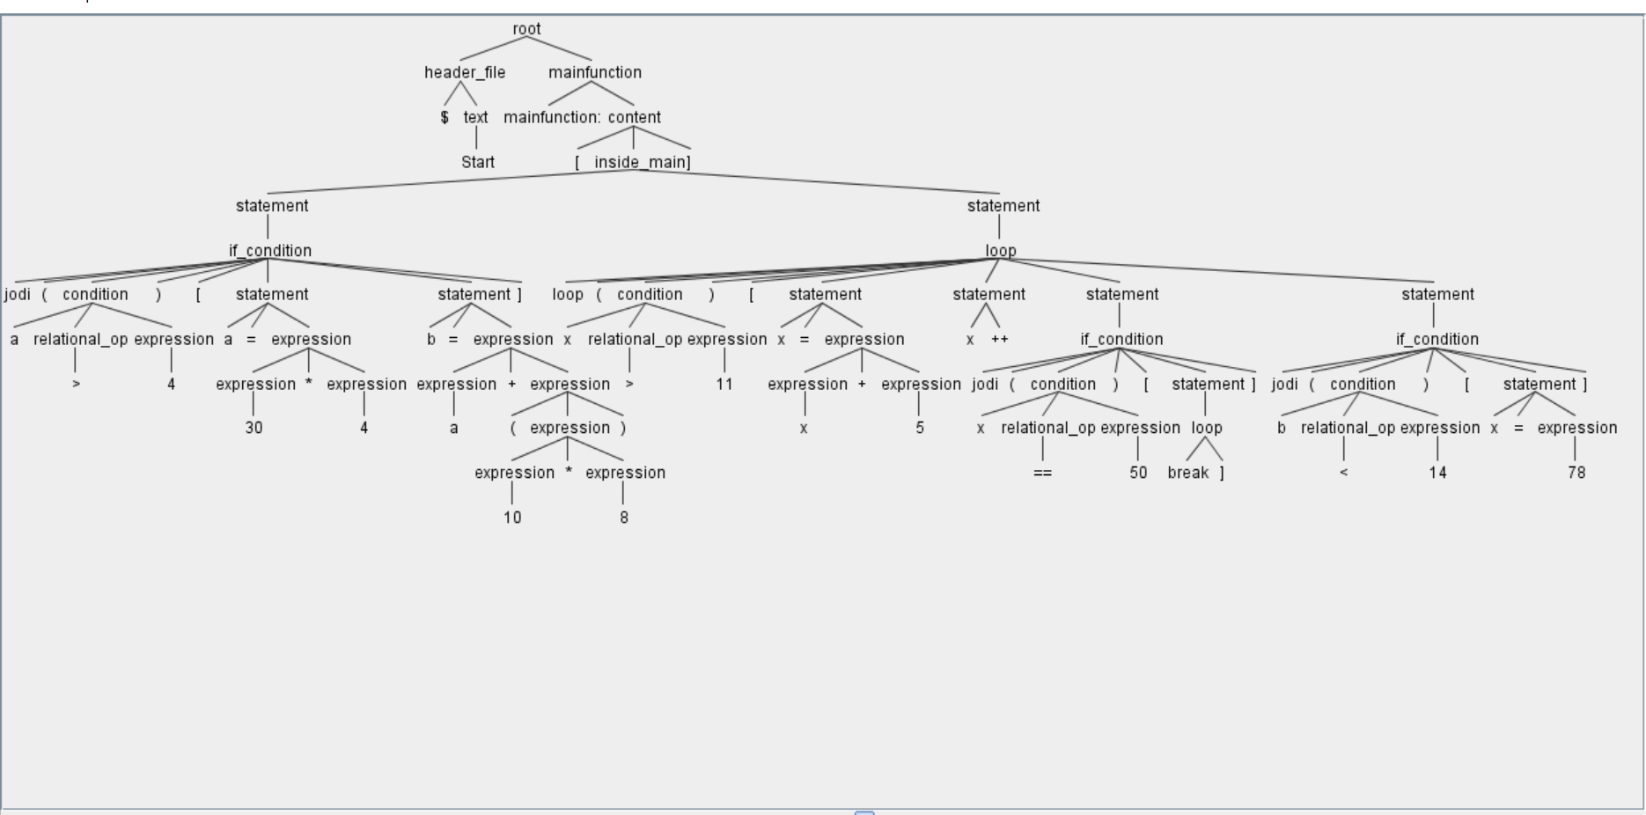

**INPUT WITH ERRORS**

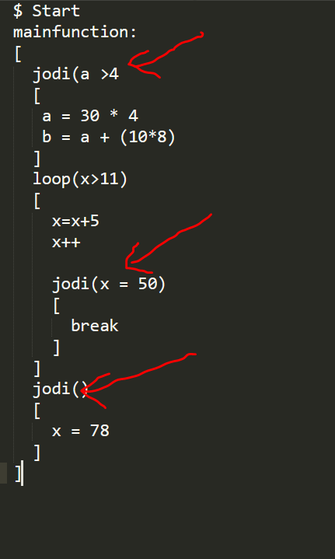

**ERROR SHOWING IN PARSE TREE**

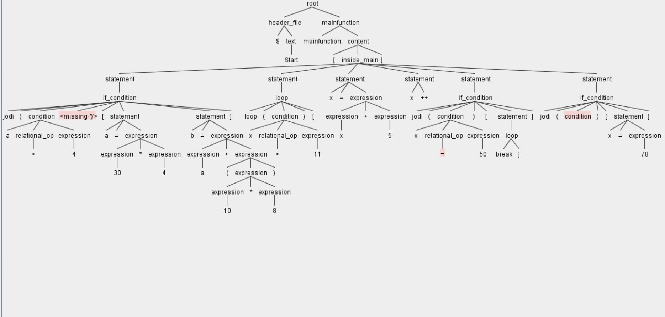

**ERROR SHOWING IN CMD**

